AI-Based Adaptive User Interface for Improving Human–Computer Interaction

Shiva Sai Reddy Gayam
University of Cumberlands
Artificial Intelligence for Human-Computer Interaction
Dr. Jennifer Merritt
2026

Introduction
Artificial Intelligence in User Interfaces
Artificial Intelligence (AI) is now a vital element of today's digital systems, especially when it comes to creating and developing user interfaces. While traditional user interfaces made it necessary for users to manually search and change settings according to their requirements, AI has changed this. AI has made user interfaces so smart that they can respond and customize themselves to the users' needs. Not only do these interfaces study users by watching their behavior and identifying their likes and interaction styles, but they also provide personalized experiences that help the users to be more effective and make things easier for them. Besides, AI interfaces remember users' past interactions and modify responses/manner of behavior, thereby making user experience better. For instance, several websites employ AI techniques to suggest products, modify layouts of displays, and offer ticket attendants through the virtual assistant and chatbot program (Wang et al., 2024).
Furthermore, AI gives the possibility for systems to understand difficult user inputs including voice commands, gestures, and natural language questions. As a result of speech recognition, natural language processing, and predictive analytics organisms, users can communicate with systems in the most natural and simple way possible. Consequently, AI-powered interfaces simplify and facilitate human-computer interaction and consequently make technology available to more users. As a result, this development has drastically changed how people use digital devices, websites, and applications in not only their everyday life but also in industries like healthcare education e-commerce, and entertainment (Hussain et al., 2024)
Importance of Adaptive Systems
Adaptive systems are essential in making AI-enhanced user interfaces more effective. A system being adaptive means that it can change its actions, configuration, or appearance automatically when it detects changes in user preferences, environment, or usage patterns. In contrast to non-adaptive interfaces that offer the same experience to all users, adaptive systems tailor the interaction to the individual user. Such customization is one of the major benefits that help mitigate user fatigue, increase efficiency, and boost user satisfaction when using digital systems (Hussain et al., 2024).
The most prominent feature of adaptive systems is that they get to know their users through the latter's interactions and make changes in a number of interface aspects in real time, for example by changing the layout colors font sizes, or suggesting new content. One may see this practice in streaming services that look at what a user has watched in order to recommend new content or in mobile applications that switch automatically to dark mode depending on user preferences or the time of day. Such adaptations are part of user-centered design whereby the main focus is on user's convenience and efficiency (Jiang et al., 2025).
Besides that, adaptive systems are beneficial for accessibility as they can tailor the interfaces to different users depending on their abilities or tec skills. By creating personalized interaction spaces, these systems alleviate various obstacles and also make technological experience more inclusive. Equipped with AI technologies evolving rapidly, adaptive systems are expected to become a key element in the design of smart interfaces that would facilitate human-computer interaction and upgrade the overall quality of digital experiences (Hussain et al., 2024).
Definition and Concept of Adaptive User Interfaces
Adaptive user interfaces or AUIs refer to computer systems that tailor their design, components, or features to the individual user's preferences, behavior, and requirements. They are quite different from conventional static interfaces that offer the same look and interaction style to all users. Adaptive interfaces constantly change the user experience based on the user's interaction history and other environmental factors. Such systems use AI methods like machine learning, user modeling, and data analytics to track users' usage of the software and then accordingly change the interface. The primary purpose of adaptive user interfaces is to enhance user-friendliness, lessen mental strain, and deliver a highly tailored interaction experience. By deciphering user likes and usage, adaptive interfaces can adjust their components like navigation schemes, visual arrangements, and modes of interaction to fit individual users more effectively (Wang et al., 2024).
How Adaptive Interfaces Work
Adaptive interfaces continuously track and study users' behaviors while they interact with the system. Usually, the work of an adaptive interface is divided into three main stages: collecting data, forming a user model, and changing the interface. Initially, the system monitors the users' behavior, e. g. what features they use most, their navigation paths, and times of interactions. Then, the system makes a user model, a representation of the user which may include user's preferences, skills, or habits. The interface is changed either in the way it looks or the way it works based on the user model. For instance, the system can make the font larger automatically for users who zoom in often, the menu with options can be made simpler for the users who are experts, and the tools that are used most of the time can be exposed to the users who are habitual. Adaptive interfaces through this everlasting process of watching and changing, get used to and understand the users better (Jiang et al., 2025)
Examples of Adaptive User Interfaces
Nowadays, adaptive interfaces are incorporated into many digital platforms and applications. For instance, streaming services keep track of what users watch and suggest content tailored to them; online shopping platforms show product suggestions based on the user's browsing and purchase history. Adaptive behavior is seen in mobile operating systems too, as they decide on the brightness of the screen, activate dark mode, or suggest applications based on user routines. Navigation systems change route recommendations according to the condition of the traffic and the user's history of traveling. Educational platforms to deploy adaptive interfaces for delivering personalized learning content that match students' pace and academic performance. These examples serve to show that adaptive systems have the potential to help users by making them more efficient and by making the experience of using a system more convenient (Jiang et al., 2025)
Benefits of Adaptive User Interfaces
There are a number of significant benefits to relying on adaptive user interfaces. To start with, they help to boost user happiness thanks to delivering tailor-made experiences that fit the unique tastes of each one. Usability-wise, they can make things easier on users as they don't have to configure settings or locate favorite features as much. Actually, adaptive interfaces also ramp up accessibility side by side with system modifications that serve users with different skills or ways of using technology (Wang et al., 2024).
Adaptive systems can lead to higher output as they make feature info stand out while limiting areas that aren't so necessary. With digital technologies further changing, adaptive UIs are nowadays regarded as the very core elements of software nowadays - running the show for organizations to bring smarter, faster, and more personal digital journeys.
Definition of Intelligent User Interfaces (IUIs)
IUIs or Intelligent User Interfaces are not merely a computer interface but a sophisticated computer interface system that incorporates AI or artificial intelligence technologies to make human-computer systems interaction more efficient. In fact, the interface design must not just include traditional elements such as graphics and icons but also the use of AI techniques that include natural language processing, machine learning, knowledge base, and predictive analytics to capture user intentions and help them perform their tasks efficiently. So, intelligent user interfaces refer to computer systems that are responsive, intuitive, and useful in decision-making processes (Kristić et al., 2025)
IUIs analyze user input and contextual information to generate a human-like conversation, automation of repetitive tasks, and personalized assistance. In a nutshell, the goal of intelligent user interfaces is to develop systems that can interact with users more naturally and effectively by first understanding them more deeply (Kristić et al., 2025).
Features and Capabilities Intelligent User Interfaces:
Intelligent user interfaces (IUIs) have a range of attributes that set them apart from regular interfaces. For starters, they can understand complex user inputs in the form of voice commands, gestures, or natural language expressions. Like, a voice assistant is able to understand spoken language and provide an answer or the relevant action. Predictive assistance is another highly valued feature of IUIs that refers to the interface being able to foresee user's needs and present options or perform automated actions. Also, intelligent interfaces support context awareness, i. e. their behavior can be modified based on external factors such as location, time, or device. Collectively, these features enable IUIs to offer significantly more efficient and highly customized user experiences than do traditional interface designs (Kristić et al., 2025).
Software Solution Summary of the Developed Program
The program illustrated an adaptive user interface concept using artificial intelligence principles. For this, a simple desktop application was created with Python in the PyCharm programming environment. The app was meant to mimic an AI-based adaptive interface that changes its look automatically according to user preferences and past interactions. It includes a graphical user interface where users can change some features of the interface, for instance, the choice of theme and text size. The system collects these user preferences and continues to use them without asking the user every time the app starts. Such a method shows that adaptive systems are capable of recognizing user behavior and therefore change the interface to suit the user's needs, which may lead to a better overall experience.
The app implements a few interactive elements that can be used to customize the interface. For example, users may opt for dark mode or light mode, depending on which one they find more comfortable visually. Besides this, the application offers a way for users to step up or step down font size. Each time a user modifies these settings, the program saves the option selected in the local data file. Once the app is launched, it accesses the stored preferences and carries them out without depending on the user to change them again manually. This example illustrates the main idea behind adaptive interfaces, i. e. devices that modify their functioning based on the history of user interaction (Kristić et al., 2025).
Adaptive Behavior of the System
Adaptive system behavior is achieved through the incorporation of a very basic user preference learning mechanism. When users change interface settings, the application tracks their actions. These settings changes, or interactions, are treated as user preferences and recorded in a structured data file in JSON format. Later, during program startup, the system fetches these preferences and changes the graphical interface to align with them. Essentially, this is user modeling done in a very simplistic way, where the system keeps a record of the user's preferences and uses that for personalizing the interface.
Say a user opts for dark mode and decides to enlarge the font size in a single session. These settings get stored. The next time the application is opened, it will be in dark mode with that font size. This way, users don't have to adjust the settings every time, thus making their experience more comfortable and personalized. Even though the adaptive mechanism implemented in this project comprises simple rule-based decision-making without relying on complex machine learning models, it serves quite well to illustrate the notion of AI-driven adaptive human-computer interaction. The system examines the user's behavior and alters its response so that it is in line with what the user is expecting (Kristić et al., 2025).
Technologies Used
The development of an adaptive user interface application involved the use of various technologies. Python was the main programming language for this project due to its ease of use and abundant resources for AI and UI development. The user interface of the application was created with the help of the Tkinter library, which is a standard Python toolkit capable of building desktop applications with graphical elements like windows, buttons, and labels (Hussain et al., 2024).
Together with Tkinter, the JSON data format was utilized for storing user preferences in a light and organized manner. This file serves as a basic user model to keep track of the user's past interactions with the system. The PyCharm Integrated Development Environment (IDE) was adopted for coding, testing, and debugging. PyCharm offers great features like syntax highlighting, debugger, and project management which dramatically help developers in creating and testing their applications efficiently. Using a combination of Python Tkinter JSON storage, and PyCharm development tools, this project effectively shows how the ideas of adaptive user interfaces can be realized in a basic software prototype (Hussain et al., 2024).
OUTPUT
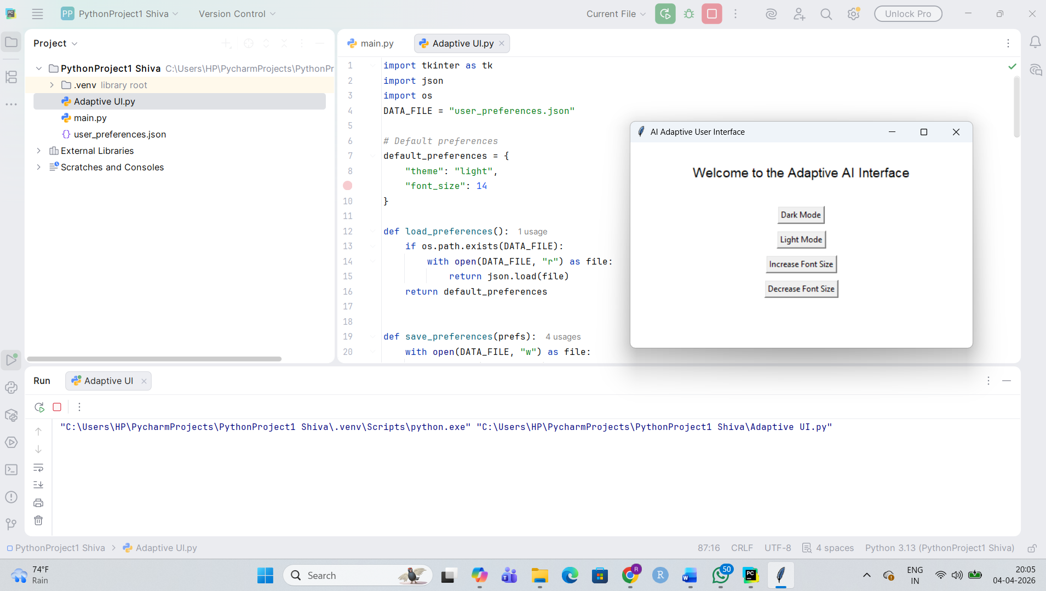
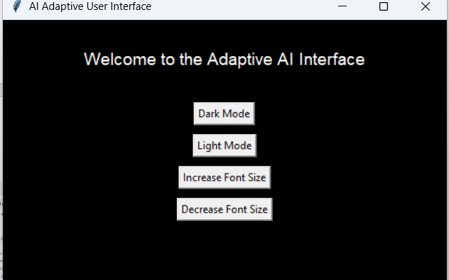
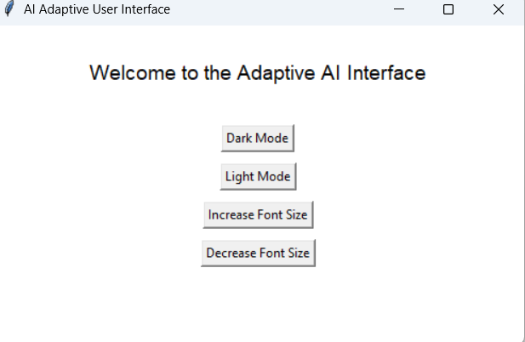
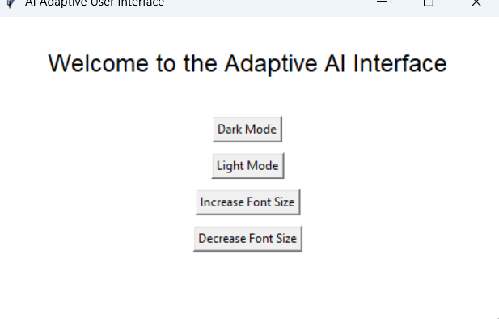
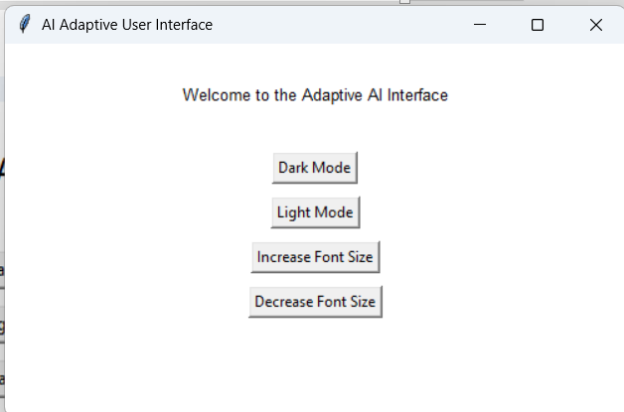
Conclusion
Artificial intelligence has altered users' experience with the latest computer systems considerably by providing more intelligent and personalized interaction models. Conventional user interfaces require users to adjust settings manually and explore through a fixed layout, which may not always fit the user's needs. Meanwhile, AI-powered adaptive and intelligent user interfaces examine user behavior and adjust system characteristics to enhance utility and effectiveness without the user's intervention. Such adaptivity skills enable the systems to offer tailored experiences that improve user contentment and lessen the human efforts to operate digital platforms.
The software prototype of this project features a simple illustration of an AI-driven adaptive user interface with the help of Python programming language and Tkinter GUI toolkit. The program keeps track of user personal settings like selecting a theme and changing font size and will automatically implement these settings when the program is launched again. This is an example of human-computer interaction that changes according to user behavior through user modeling and preference learning. Although the demo used elementary rule-based methods instead of really complex machine learning methods, it still managed to depict rather effectively the basic aspects of design of the adaptive interface.
Finally, adaptive and intelligent user interfaces are becoming indispensable components of the software industry as they raise the levels of accessibility, personalization, and efficiency. As AI technology is progressing, future machines will have more sophisticated learning mechanisms and context-awareness capabilities, which will lead to a better interaction between humans and computer systems.

References
Hussain, I., Khan, I. A., Jadoon, W., Jadoon, R. N., Khan, A. N., & Shafi, M. (2024). Touch or click friendly: Towards adaptive user interfaces for complex applications. PLoS ONE, 19(2), e0297056. https://doi.org/10.1371/journal.pone.0297056
Jiang, M., Huang, J., & Wang, L. (2025). Adaptive user interfaces for wearable medical devices using deep Q-learning and Golden Jackal Optimization. Scientific Reports, 15, Article 44776. https://doi.org/10.1038/s41598-025-28937-z
Kristić, M., Zakarija, I., Škopljanac-Mačina, F., & Car, Ž. (2025). Machine learning for adaptive accessible user interfaces: Overview and applications. Applied Sciences, 15(23), 12538. https://doi.org/10.3390/app152312538
Wang, W., Khalajzadeh, H., Grundy, J., Madugalla, A., McIntosh, J., & Obie, H. O. (2024). Adaptive user interfaces in systems targeting chronic disease: A systematic literature review. User Modeling and User-Adapted Interaction, 34, 853–920. https://doi.org/10.1007/s11257-023-09384-9

